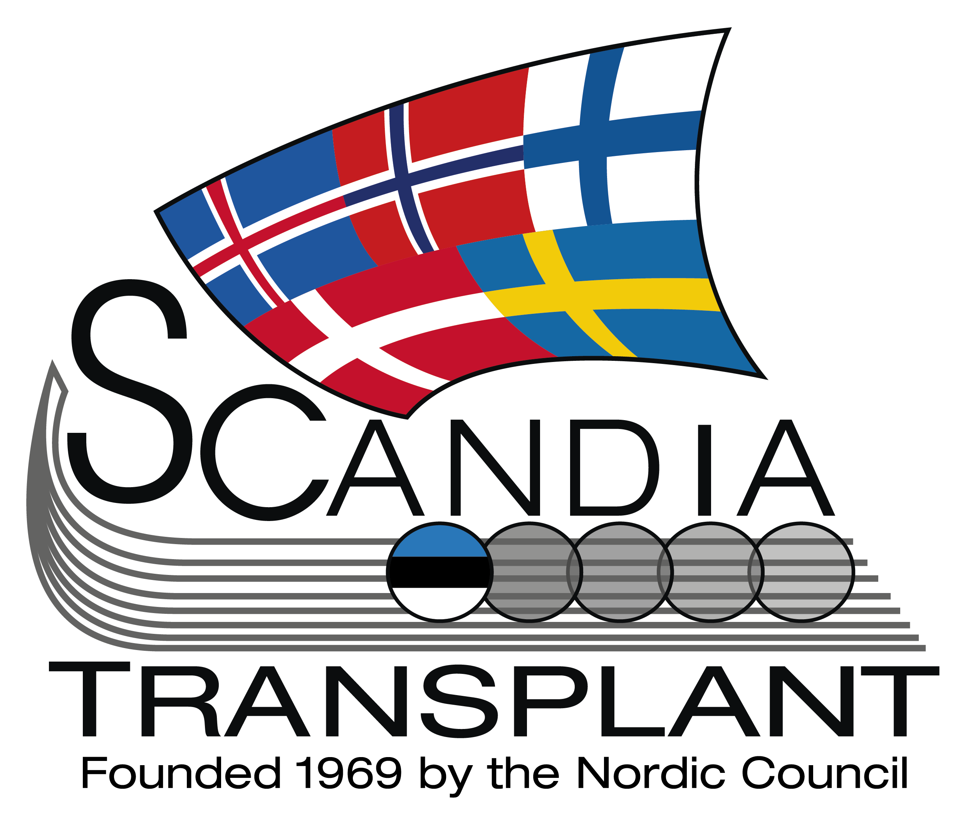
Scandiatransplant living donor database

Initial registration Donor number:

I Basic information:

● Donor name:

[surname / first name]
● Birth number:

● Sex: Male Female

● Country of residence: Sweden Denmark Finland Norway Iceland Estonia

Hospital of diagnostic evaluation and/or follow up
● Local hospital: ________________________

● Procuring Center: ______________________

● AB0 blood group: A B 0 AB

● Relation to recipient:
AD: Anonymous Donor
BSL: Brother/Sister-in-law
CHA: Co-habitant
CO: Cousin (first)
COS: Second cousin
DA: Daughter
FA: Father
FRI: Friend
GRC: Grand-child
GRP: Grand-parent
MO: Mother
OFL: Other familial linkage
OTC: Not Scandiatransplant
OTR: Other related
OTU: Other unrelated
SI: Sibling, no haplo spec
SI0: Sibling, 0 haplo id
SI1: Sibling, 1 haplo id
SI2: Sibling, 2 haplo id
SO: Son
SP: Spouse
UA: Uncle/Aunt
Other, specify

● Birth number of recipient:

II Preoperative data

● Height: |  |  |  |  | cm
● Weight: |  |  |  |  | kg
● Organ type:
Kidney left
Kidney right
● Any previous urinary tract disease/condition:
→ No
→ Yes
→ Glomerular/instertit. Disease
→ Significant Urinary Tract Infection(s)*
→ Hematuria (micro-/macro-)
→ Urolithiasis
→ Tumor
→ Renal anomaly/Other renal disease
→ Other UT disease/condition

Comment: _____________________________________________________
*Definition of Significant Urinary Tract Infection(s):
♂: Any UTI
♀: Any pyelonehritis. >1 lower UTI/cystitis per 10 years of age

● Kidneys/vessels evaluated by:
Ultrasound
Angiography; conventional/invasive
Rtg. urography
Renography (isotope-)
CT/-angiography
MR/-angiography

● Split function right: _____________ %
● Split function left: ______________%

● Number of arteries: ______________
● Number of veins: ______________
● Any anomalies: ___________________________________________________________

III Virology and bacteriology (infection serology)

CMV: Anti-CMV (Cytomegalovirus) | Neg | Pos | ND
Covid: SARS-CoV-2 RNA (Covid-19)
CovAb: Anti-SARS-CoV-2 (Covid-19 antibody)
EBV: Anti-EBV IgG (Epstein-Barr)
HBc: Anti-HBc (antibody)
HBsAb: Anti-HBs (antibody)
HBsAg: Hepatitis Bs antigen
HCV: Anti-HCV (antibody)
HCVAg: Hepatitis C antigen (RNA)
HDV: Hepatitis Delta Virus (antibody)
HIVab: Anti-HIV (antibody)
HIVag: HIV antigen
HSV: Anti-HSV (antibody)
LUES: Syphilis antibody
MV: Anti-MV IgG (Morbilli antibody)
TOXO: Toxoplasma antibodies
VZV: Varicella zoster virus
Other positive infectious parameter |  |  |  |  |  | Comments:

IV HLA typing

Serological:
 | A |  | B |  | Bw4/w6
 | Cw |  | DR |  | DQ
Genomic:
 | A |  | B |  | C
 | DRB1 |  | DRB3/4/5 |  | DPA1
 | DPB1 |  | DQA1 |  | DQB1

V Baseline risk factors
During evaluation or at admission

● p-Cholesterol: mmol/l

● p-Triglycerides: mmol/l

● p-HDL: mmol/l

● p-LDL: mmol/l

● Anti-lipid drugs; number of:

● Smoking? [1 choice of 3]:
Previously > 3 years smoking or > 3 “pack years” (not at present)
→ No
→ Previously
> 3 cigarettes per week

→ At present

The representative pressure for donor acceptance.
with or without antihypertensive drugs
● Systolic blood pressure: |  |  |  |  | mmHg
● Diastolic blood pressure: |  |  |  |  | mmHg

● Anti-hypertensive drugs; number:

● Comorbidity:
→ Yes |  | Specify: ___________________________
→ No
→ ND

● Other ongoing medication:
→ Yes |  | Specify: ___________________________
→ No
→ ND
VI Kidney function

● Plasma indicators:

→ Creatinine: μmol/l

→ Cystatin C: mg/l

● Glomerular Filtration Rate:

→ Creatinine Clearance: ml/min

→ Cr-EDTA Clearance: ml/min

→ Iohexol Clearance: ml/min

Estimated clearance, auto calculated in YASWA:
Cockroft formula: Weight (kg) • (140 – Age (years)) • C • 1/Creatinine (μmol/l)
♂: C = 1,23 ♀: C = 1,23 • 0,85 (1/1000 • kg • years • min)

● Proteinuria
No, if: < 0.5 g protein/ 24 hours ∩ < 0.3 g albumin/ 24 hours
→ No
→ ND
→ Yes
 |  | → Single miction: Sticks
 |  | → 24-hour urine: Protein assay |  |  |  |  | g
 |  | → Single miction: Alb.-/Creat.-assay |  |  |  |  | mg/mmol
 |  | → Single miction: Protein-assay |  |  |  |  | g

● Microalbuminuria

→ No |  | No, if: < 30 mg albumin/24 hours
→ ND
→ Yes
 |  | → Single miction: Sticks
 |  | → 24-hour urine: pro alb: |  |  |  |  | g
 |  | → Single miction: Alb.-/Creat.-assay |  |  |  |  | mg/g |  |  |  |  |  |  |  |  |  |  | mg/mmol

● Diabetes/Pre-Diabetes ?

→ No
→ ND
→ Yes
 |  | → Year of diagnosis
 |  | → Specify
 |  | → Treatment | None
 |  |  | Diet
 |  |  | Peroral anti-diabetic drugs
 |  |  | Insulin

VII Donor operation

● Date of operation:

● Operative technique

→ Open
→ Flank incision: → Costal resection: No: Yes:
→ Subcostal/ventral and retroperitoneal:
→ Subcostal/ventral and transperitoneal:

→ Scopic
→ Laparoscopic (transperitoneal)
→ Retroperitoneoscopic
→ Converted to open*

→ Strict scopic:
→ Hand-assisted with handport:
→ Hand-assisted without handport:

* Conversion,

reason

→ Combined procedures
(not only hand-assisted)
→ Open during caval exclusion:
→ Other modification

Comments:

● Number of renal arteries

● More arteries after division Yes: No:

● Art. not dem. by an.gr Yes: No:

● Preoperative complications/incidents:
→ No
→ ND
→ Yes
 |  | → Bleeding requiring transfusion |  | Units of blood
 |  | → Visceral perforation
 |  | → Lesion of renal vessel(s)
 |  | → Other perop. complication
 |  | → Renal tumor
 |  | → Kidney discarded Yes: No:
Comments:

“Skin to skin” time
- Inactive time may be subtracted
(e.g. waiting for recipient)

● Operative time: min

● Anesthetic time: min
Intubation to extubation

VIII Postoperative data
Within 30 days post donation
● Postoperative complications/incidents:
→ No
→ Yes
→ Bleeding requiring transfusion → Units of blood postop.:

→ Wound complications
→ Infection:

Infection; Definition:
Purulent secretion and/or + bacteriology
→Specify:

→ Lymphocele:
→Specify:

Lymphocele; Definition: Deep fluid accumulation; requiring intervention

→ Dehiscence:
→Specify:

→ Urinary tract infection

→Specify:
→ Pneumonia

→Specify:

→ Thromboembolism
→ Deep vein thrombosis: → Pulmonary embolism:
→ Other →Specify:

If not also antihypertensive medication preop.

→ Anti-hypertensive treatment
→ Other postop. complication
→ ICD-10 diagnostic code:

→ Specify:

→ Reoperation

→Specify:

Last measurement prior to discharge
● Postop kidney function by plasma indicators

→ Creatinine: μmol/l

→ Cystatin C: mg/l

Discharge from Tx-related department

● Date of discharge: [date; ddmmyy]

● Mental effect by donation:
→ Physically reduced capacity

→ Mentally reduced capacity

→ Negative experiences/mental effect

→ Positive experiences/mental effect

Specify:

Follow-up at 3 months – n years post-donation

I Basic information:

● Donor number

● Donor name:

[surname / first name]
● Birth number:

● Date of consultation: ________________

● Next follow up: ________________

● Lost to follow up

● Telephone surgery
→ Date of contact: ___________________
→ Comments:

Unemployed, pensioner etc:
0 weeks

● Weeks out of work due to donation: weeks

● Have you suffered economic loss due to donation ?
→ No – no problem with compensation
● Loss of income
● Altered working conditions
● Aid at home/children
● Cover charges/drugs etc
→ No – but troublesome compensation

→ Specify:
→ Yes
→ Specify:

II Restitution
Full restitution: No difference in negative direction compared with the predonation status

Date of full restitution: ______________

● Overall Positive effect of donation (somatic/mental)
→ Positive experiences/mental effect by donation
→ Negative experiences/mental effect by donation

Specify:

● Overall Negative effect of donation (somatic/mental)
→ Mentally reduced capacity
→ Negative experiences/mental effect by donation
→ Positive experiences/mental effect by donation
→ Physically reduced capacity

● Pain (relating to donation)
→ Analgesic drugs?
→ Every day
→ Sporadically
→ Seldom/Never

→ Location/type; specify briefly:

III Complications

● Late complication or readmission related to donation?
> 30 days post-donation
→ No
→ ND
→ Yes
→ Wound complications

→ Hernia / protrusion → Specify:
→ Lymphocele/(seroma) → Specify:
→ Sensory disturbance/ → Specify:
hyperesthesia (significant)
→ Uremia → [2 of 2]:
→ Dialysis: No: Yes:

→ Specify disease - - - - - - - :

Specify reason for readmission, diagnosis, and type of reoperation/
intervention.
→ Readmission → Specify:
→ Reoperation → Specify:

→ Other late complication → Specify:

● Significant intercurrent disease (not clearly related to donation) or pregnancy?
→ No
→ Yes → [1-7 choices of 7]:
→ Urinary tract disease → [1-6 choices of 6]:
→ Urinary Tract Infection(s)

→ Specify:
→ Hematuria (micro-/macro-)
→ Specify:
→ Urolithiasis
→ Specify:
→ Tumor → [1-2 of 2]:
→ ICD-10 diagnostic code: [Xnn.d]

→ Specify:

→ Renal anomaly → [1-2 of 2]:
→ ICD-10 diagnostic code: [Xnn.d]

→ Specify:

→ Glomerular/interstit. disease → [1-2 of 2]:
→ ICD-10 diagnostic code: [Xnn.d]

→ Specify:

→ Other UT disease/condition → [1-2 of 2]:
→ ICD-10 diagnostic code: [Xnn.d]

→ Specify:

→ Cardiovascular disease
→ Specify:

→ Pulmonary disease
→ Specify:
→ Thromboembolism → [1-3 of 3]:
→ Deep vein thrombosis: → Pulmonary embolism:

→ Other →Specify:

→ Other infectious disease

→ Specify:

→ Other intercurrent disease
→ Specify:

→ Pregnancy

→ Specify:

● Death?
Date of death: ______________

Cause of death:

Death ICD-10 code: ________________
IV Risk factors

● Height: |  |  |  |  | cm
● Weight: |  |  |  |  | kg

● p-Cholesterol: mmol/l

● p-Triglycerides: mmol/l

● p-HDL: mmol/l

● p-LDL: mmol/l

● Anti-lipid drugs; number of:

Previously > 3 years smoking or > 3 “pack years” (not at present)
● Smoking?
→ No
→ Previously
> 3 cigarettes per week

→ At present

The representative pressure –
with or without antihypertensive drugs
● Systolic blood pressure: mm Hg

● Diastolic blood pressure: mm Hg

● Anti-hypertensive drugs; number:

V Kidney function

→ Creatinine: μmol/l

→ Cystatin C: mg/l

● Glomerular Filtration Rate:

→ Creatinine Clearance: ml/min

→ Cr-EDTA Clearance: ml/min

→ Iohexol Clearance: ml/min

Estimated clearance, auto calculated in YASWA:
Cockroft formula: Weight (kg) • (140 – Age (years)) • C • 1/Creatinine (μmol/l)
♂: C = 1,23 ♀: C = 1,23 • 0,85 (1/1000 • kg • years • min)

If, no: < 0.5 g protein/ 24 hours ∩ < 0.3 g albumin/ 24 hours
● Proteinuria
→ No
→ ND
→ Yes
 |  | → Single miction: Sticks
 |  | → 24-hour urine: Protein assay |  |  |  |  | g
 |  | → Single miction: Alb.-/Creat.-assay |  |  |  |  | mg/mmol
 |  | → Single miction: Protein-assay |  |  |  |  | g

● Microalbuminuria
→ No |  | No, if: < 30 mg albumin/24 hours
→ ND
→ Yes
 |  | → Single miction: Sticks
 |  | → 24-hour urine: pro alb. |  |  |  |  | g
 |  | → Single mictation: Alb.-/Creat.-assay |  |  |  |  | mg/g |  |  |  |  |  |  |  | mg/mmol

5. Diabetes mellitus
→ No
→ ND
→ Yes
 |  | → Year of diagnosis
 |  | → Diagnostic criteria / level of disease
 |  | → Treatment | None
 |  |  | Diet
 |  |  | Peroral anti-diabetic drugs
 |  |  | Insulin

